

User Guide
Wholesale Portal
Billing Dispute GUI

Date: 04/30/2009

This document is protected under the copyright laws of the United States and/or other countries as an unpublished work. This document contains information that is proprietary and confidential to Hawaiian Telcom Inc. and its affiliates, which shall not be duplicated, used, or disclosed in whole or in part for any purpose. Any use or disclosure in whole or in part of this information without the express written permission of Hawaiian Telcom, Inc. and/or its affiliate(s) is prohibited.
© 2006 Hawaiian Telcom, Inc. and/or its affiliate(s) (Unpublished). All rights reserved.

Table of Contents

Relevant Information for Users 2
Overview of the Wholesale Billing Dispute GUI 3
Wholesale Billing Dispute GUI 5
Login Process 6
Module 1. User Functions 8
User Functions : Submit a Billing Dispute 10

Relevant Information for Users

Purpose of this course | This document will focus on the functionality of the Hawaiian Telcom Wholesale Billing Dispute GUI.
Materials and Systems that will be Used in this Course | Hawaiian Telcom Wholesale Billing Dispute GUI
System Administrator Reach Information | SA Name: Mike Hanki  Email: mike.hanki@hawaiiantel.com

Overview of the Wholesale Billing Dispute GUI
Introduction | This course covers the functionality of the Hawaiian Telcom Wholesale Billing Dispute GUI. The Wholesale Billing Dispute GUI resides on the Hawaiian Telcom homepage in the Wholesale Portal and is run via Java Server Pages (JSP).  The Wholesale Billing Dispute GUI is used by the Competitive Local Exchange Carrier (CLEC) community to submit billing disputes to the Hawaiian Telcom Wholesale Call Center for offline handling.
Objectives | By the end of this course, you should be able to perform the following functions:  - Navigate to the Wholesale Billing Dispute GUI  - Login to the Wholesale Billing Dispute GUI  - Perform User Functions  - Submit a Billing Dispute
Process Flow
Documentation | A link to the Billing Dispute GUI will be found on the Hawaiian Telcom homepage under Business > Wholesale > Billing > Inquiries, Claims, & Adjustments  OR at the following URL:  <https://www.hawaiiantel.com/billingdisputes/>

Wholesale Billing Dispute GUI

Navigating to the Billing Dispute GUI | Access the Wholesale Portal from the Hawaiian Telcom homepage <www.hawaiiantel.com> and click on the Wholesale link under the “Business” heading.  From the Wholesale Portal homepage, click on the “Billing” link.  From the Billing page, click on the “Inquiries, Claims, & Adjustments” link.  From the Inquiries, Claims, & Adjustments page, click on the “Hawaiian Telcom Wholesale Billing Dispute Form” link.  You will see the following login screen:
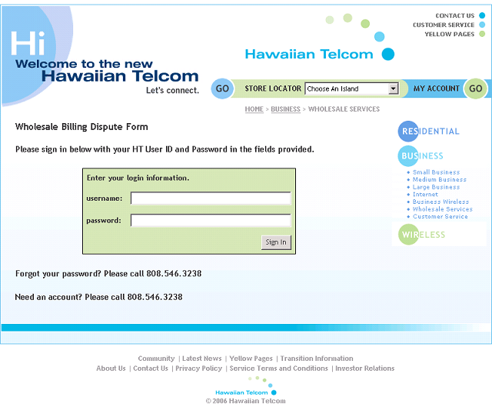

Login Process

Introduction | Navigate to the Wholesale Billing Dispute GUI using the steps described above  OR  Access the Wholesale Billing Dispute GUI by entering the following URL: <https://www.hawaiiantel.com/billingdisputes/>
Login Functionality | Enter your username and password and click the “Sign In” button to complete login.
The JSP validates the login information against the database.
- If the username and password is valid, the appropriate screen is presented to the user:
  - If the user is an administrator, the Administrator Console is presented to the user.
  - If the user is not an administrator, the Wholesale Billing Dispute Details Form is presented to the user.
Failed Login | If the username and password is not valid, the user will see the following Login Failed! Screen:
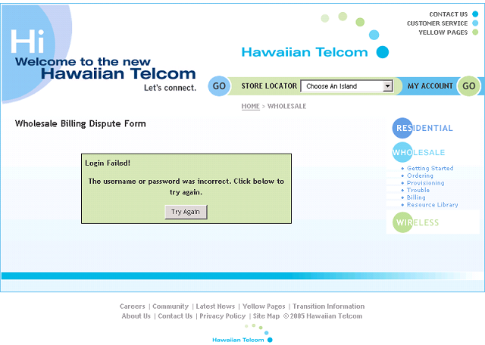

Failed Login Functionality | The Login Failed screen will contain the following functions:  - The user can attempt to login again by clicking the “Try Again” button.
 | The user can call the Wholesale Service Center 808.546.3238 (which is seen on the initial login screen) to obtain the correct login information or to setup an account

Module 1. User Functions
Introduction | This module will depict the functions users can perform on the Wholesale Billing Dispute GUI.
Objectives | At the end of this module, you will understand the functionality and content of the Wholesale Billing Dispute GUI User Functions:  - Submit a Billing Dispute
Process Flow

User Functions : Submit a Billing Dispute

Introduction | Once you have successfully logged in, you are presented with the Wholesale Billing Dispute Details Form.  A screenshot of the Wholesale Billing Dispute Details Form can be found at the end of this section.  Click here to view the screenshot
Billing Dispute Details Form Functionality | The Wholesale Billing Dispute Details Form will contain the following functions: (NOTE: Required fields are indicated with an asterisk (*); All fields are free form text with the exception of the “claim type” field.):  - Contact Information: (NOTE: All user contact information will automatically populate according to the client account records. However, the user may change any of the fields for purposes of submitting this billing dispute form.)  - Name*  - Phone*  - Extension  - Email*  - BAN*  - IXC/ACNA*  - Claim Information:  - Circuit ID / CLLI / WTN* (at least entry required and a maximum of up to 5 entries)  - Bill date in dispute*  - Claim type* (NOTE: The “claim type” field is a drop down menu, which contains the following options)  - BLK – Block  - DISC – Disconnection  - LPC – Late Payment Charges  - MRC – Monthly Recurring Charges  - NRC – Non-Recurring Charges  - RAT – Rates  - TAX – Taxes/Surcharges  - USG – Usage  - DS1  - DS3  - Claim amount*  - Description*  - Customer #  - PON*  - ASR/LSR #  - HT/SO #
 | Click the “Submit Dispute” button to submit this billing dispute form.

Wholesale Billing Dispute Details Form
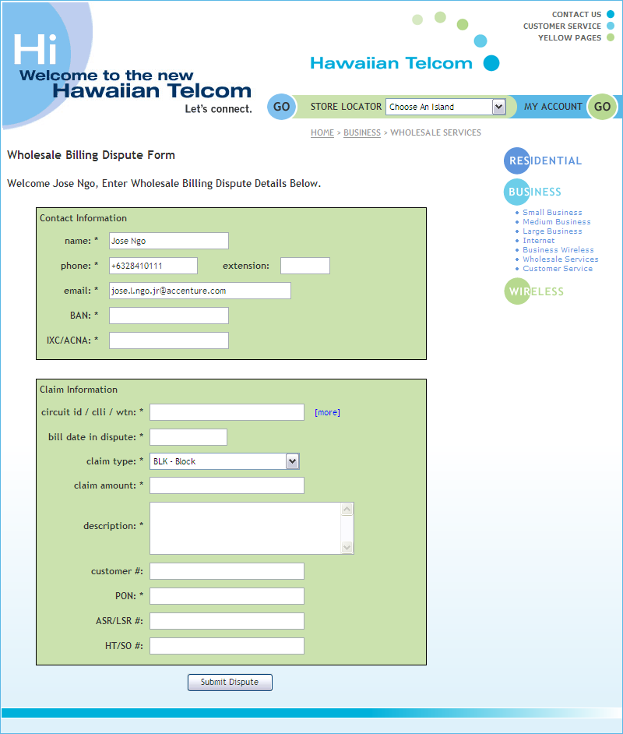

Billing Dispute Details Form Functionality (cont’) | Once you submit the billing dispute form, the JSP verifies the form has been correctly populated.  - If all required fields (fields indicated with an asterisk (*)) are populated, the JSP emails the dispute to the Hawaiian Telcom Wholesale Representative for offline handling.  - If all required fields are not populated, a pop-up error message appears:  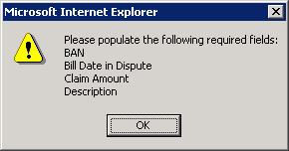  Click the “OK” button to re-populate and submit the form again.
Submission Confirmation | Upon successful population and submission, the Submission Confirmation screen appears.  A screenshot of the Submission Confirmation screen can be found at the end of this section.  Click here to view the screenshot
Submission Confirmation Functionality | The Submission Confirmation screen will contain the following functions:  - The confirmation number shown is a 17-character number, which is populated in the following way:  - yyymmddhhmmssXX  - Year (yyyy)  - Month (mm)  - Date (dd)  - Time [hour, minutes, seconds] (hhmmss)  - Users company code (XXX)

Click the “Return to Previous Page” button to return to the Wholesale Billing Dispute Details Form.

Submission Confirmation screen
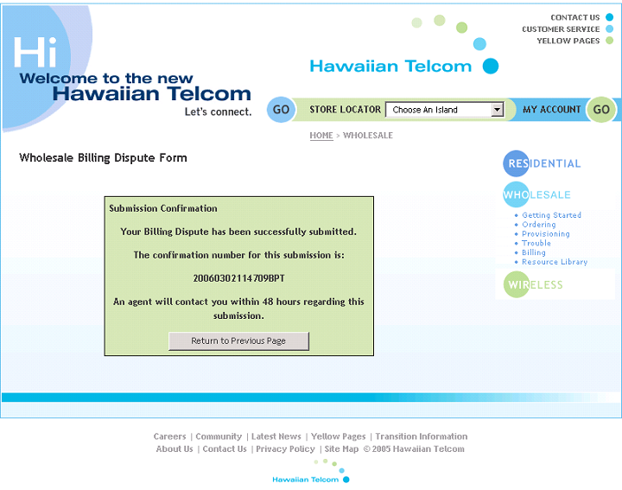

Confirmation Email | After submission, you will receive a confirmation email to the email address entered on the Wholesale Billing Dispute Details Form.
Confirmation Email Functionality | The confirmation email will contain the following information:  - The email subject line will contain the billing dispute number. (NOTE: This is the same 17-character confirmation number the user was shown on the Submission Confirmation screen)  - Example: Billing Dispute #: 20060302114709BPT  - Billing Dispute Client Account Info: (NOTE: Information shown in this section will populate according to the client account records)  - Client Name: [first last]  - Client Username: [username]  - Client Phone: [10-digit phone number]  - Client Email: [emailaddress@domain.com]  - Client Company Code: [XXX]  - Client Company Name: [Company Name]  - Billing Dispute Ticket Info: (NOTE: Information shown in this section will match the information entered on the Wholesale Billing Dispute Details Form)  - Submitted by: [first last]  - Phone: [10-digit phone number]  - Extension: [xxx]  - Email: [emailaddress@domain.com]  - BAN:  - Circuit ID / CLLI / WTN:  - Bill Date in Dispute:  - Claim Type: [xxx]  - Claim Amount:  - Claim Description:  - Customer Number:  - PON:  - ASR/LSR #:  - HT/SO #:  - Billing Dispute submitted at: [Day Month Date Time TimeZone Year]  - Example: Billing Dispute submitted at: Thu Mar 02 11:47:09 CST 2006

Confirmation Email example:
